- File Attached to Submission

A. 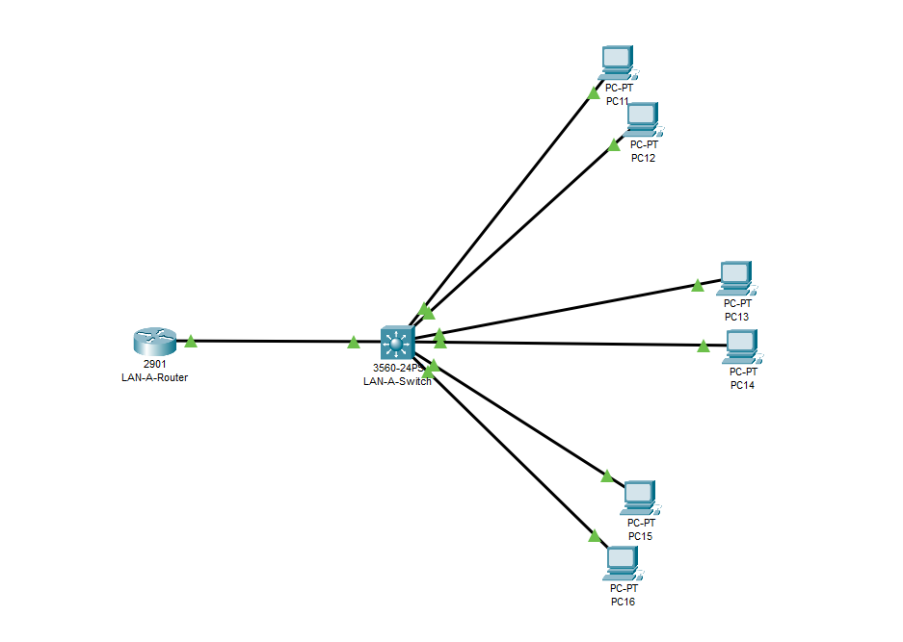

B. 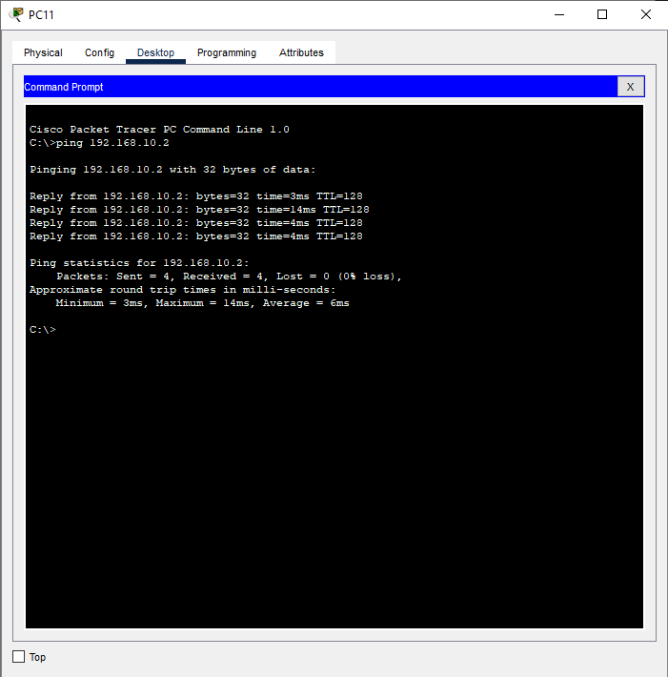

C. 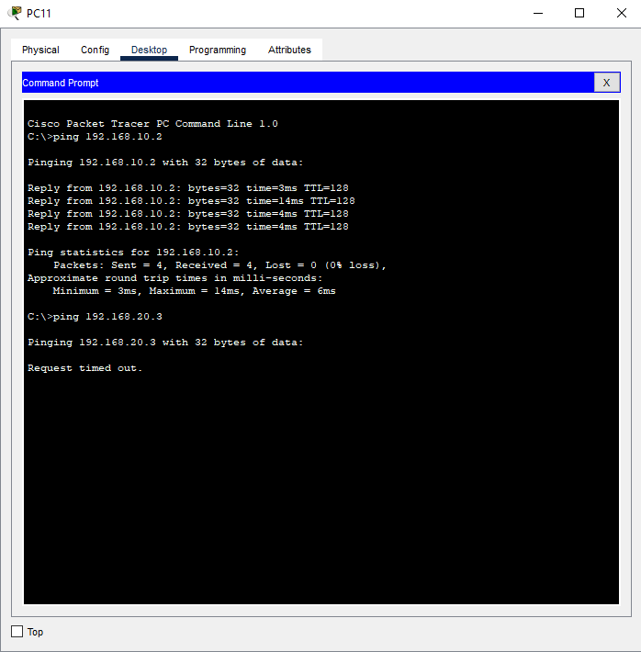

D. 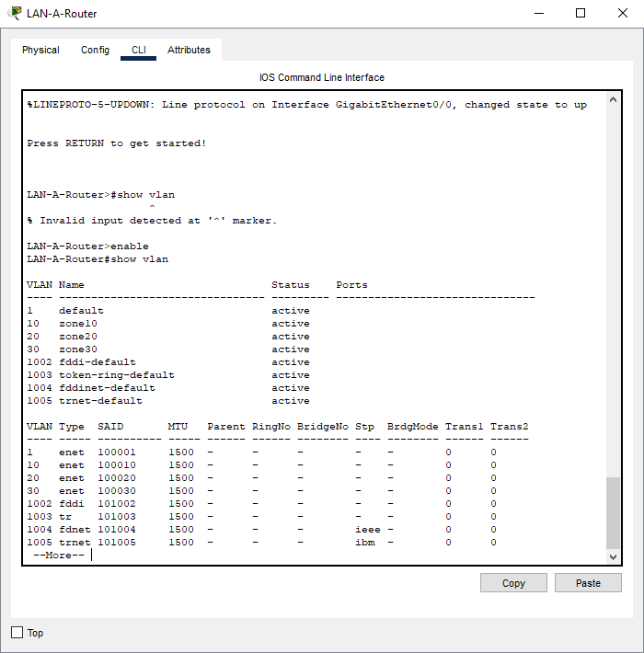

3.
A.
i. 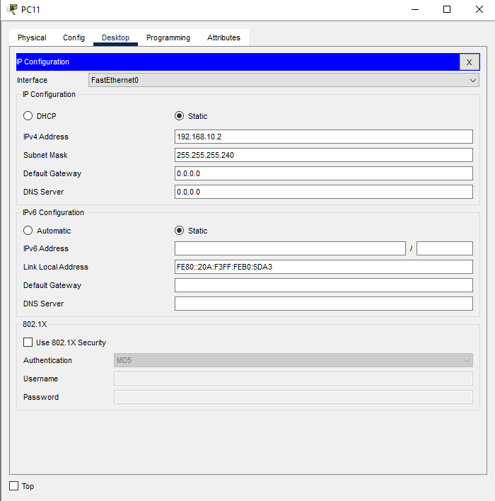
ii. 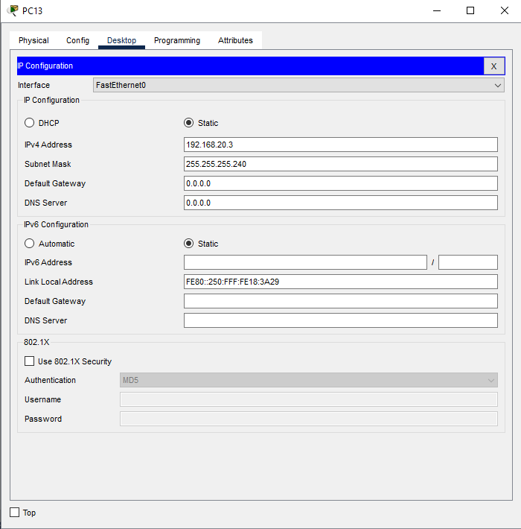
iii. 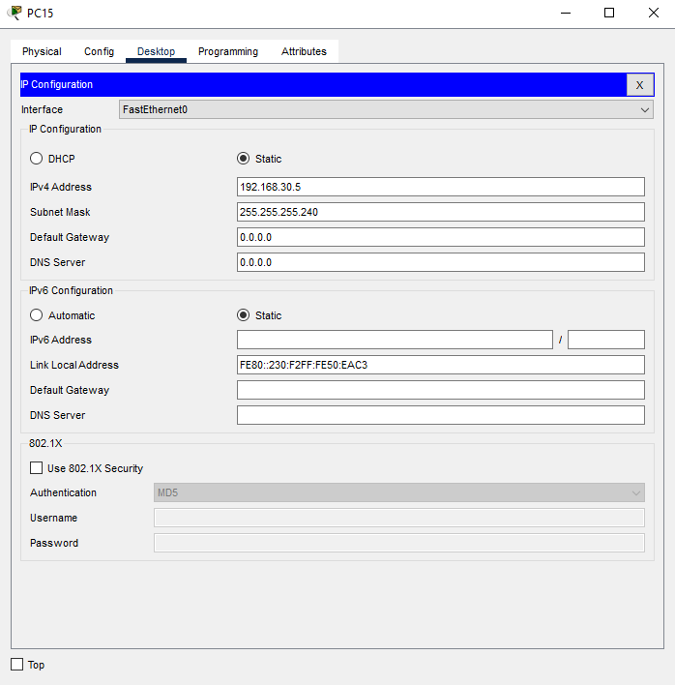
B.
i. 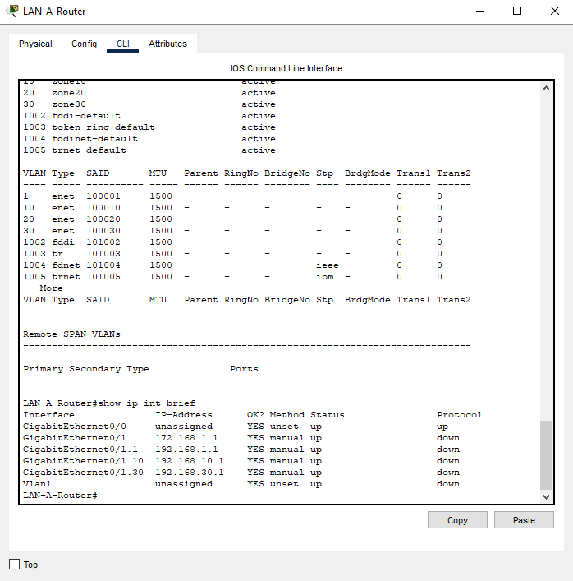
ii. 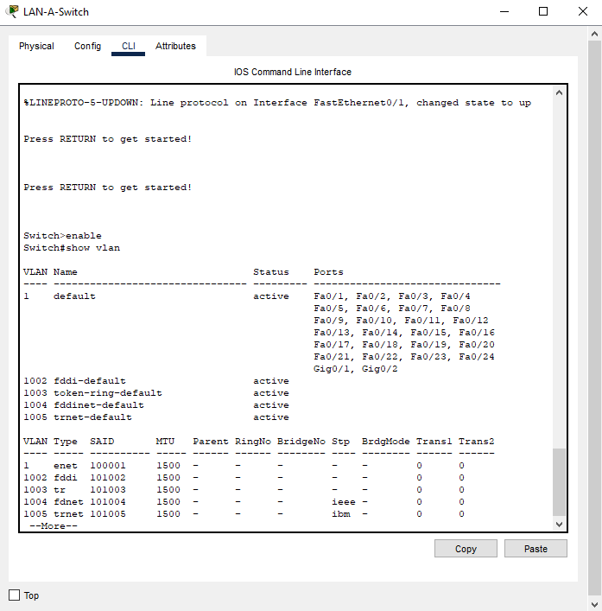
iii. Couldn’t get it to ping a workstation even though it should be able to. 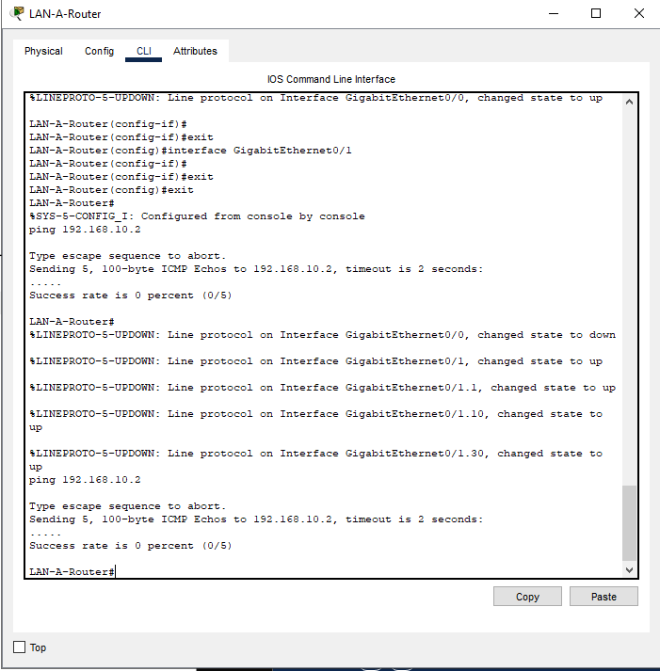
iv. 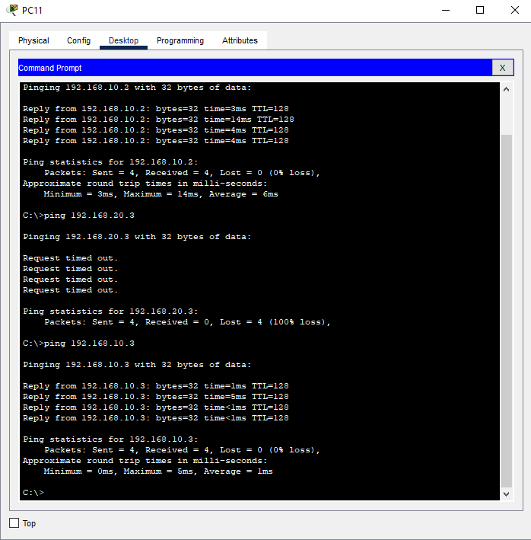

Lab 5 Questions

  - 3 sub interfaces. 10, 20 and 30.
  - Show ip interface brief
  - Show vlan
  - gi0/1, gi0/1.1, gi0/1.10, gi0/1.20, gi0/1.30

  - Subnet mask = 255.255.255.240
Binary = 11111111.11111111.11111111.11110000
  - There are 16 total addresses, 14 of which are usable.
- 100 meters
- MAC Address is a unique identifier assigned to a network interface card that identifies devices at the Data Link Layer for local network communication.
- A gateway is a router or device that connects one network to another. The purpose is to act as a forwarding device for packets destined for other networks and allows devices in one network to communicate with devices outside of their subnet.

